**PROJECT SUMMARY REPORT**

**Introduction to the Project:**

This project aims to develop a predictive model using machine learning techniques to forecast property prices based on various features such as location, size, amenities, etc. Predicting property prices accurately can be crucial for buyers, sellers, and real estate agents to make informed decisions.

**OBJECTIVES OF THE PROJECT:**

1. Develop a predictive model to estimate property prices.

2. Utilize machine learning algorithms to analyse historical property data and identify patterns.

3.Implement data preprocessing techniques to handle missing values, categorical variables, and feature scaling.

4.Evaluate the model's performance using appropriate evaluation metrics.

**LEARNING OUTCOMES**

1. Gain proficiency in data preprocessing techniques such as handling missing values and categorical variables.

2. Understand the implementation of machine learning algorithms for regression tasks.

3. Learn how to evaluate model performance using metrics like Mean . Absolute Error, Mean Squared Error, etc.

4. Enhance skills in data visualization for exploratory analysis.

**FLOW CHART OF OPERATIONS**

UNDERSTANDING PROBLEM

LOAD DATA

CLEAN DATA HANDLING MISSING VALUES , OUTLIERS

SPLIT DATA INTO FEATURES AND TARGETS

DATA PREPROCESSING

FEATURE ENGINEERING

ENCODE CATEGORICAL VALUES

SCALE FEATURES

TRAIN AND TEST SPLIT

SPLIT DATA INTO TRAINING AND TESTING

MODEL SELECTION

CHOOSE ADVANCED REGRESSSION

MODEL TRAINING AND EVALUATION

TRAIN EACH MODEL USING TRAINING DATA

EVALUATE EACH MODELS PERFORMANCE

MAEE

MSESE

RMSE

R2 SCORE

MODEL COMPARISON

HYPERPARAMETER TUNING

FINETUNE HYPERPARAMETERS

FEATURE IMPORTANCE ANALYSIS

MODEL INTERPRETATION

END

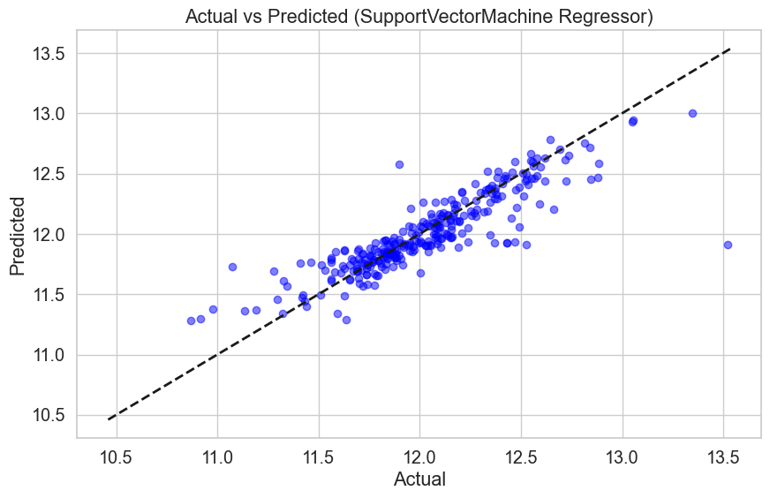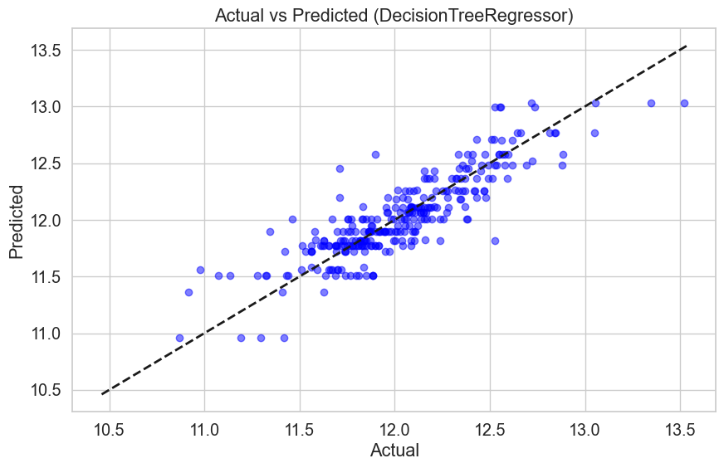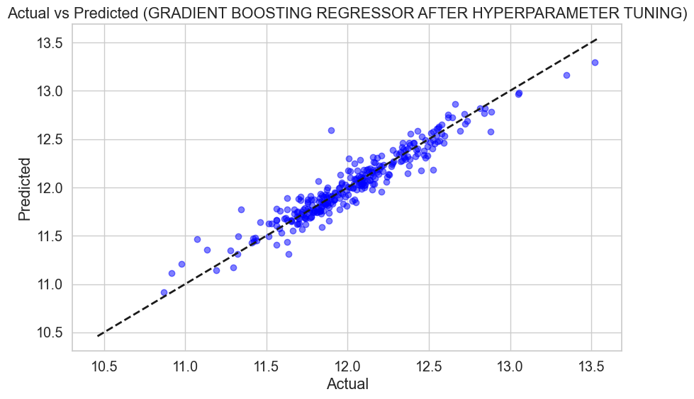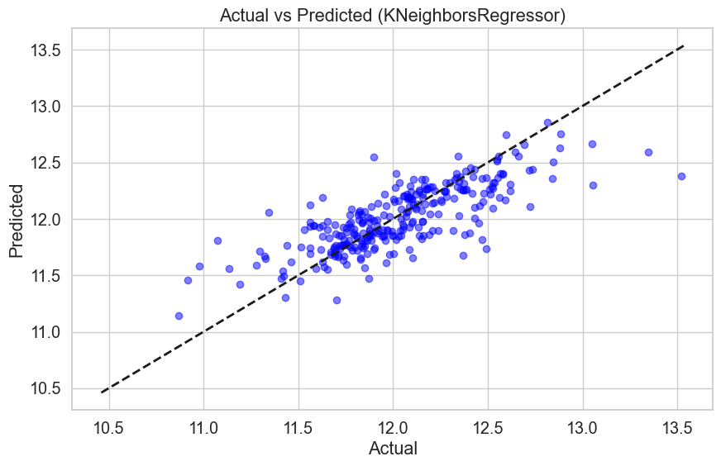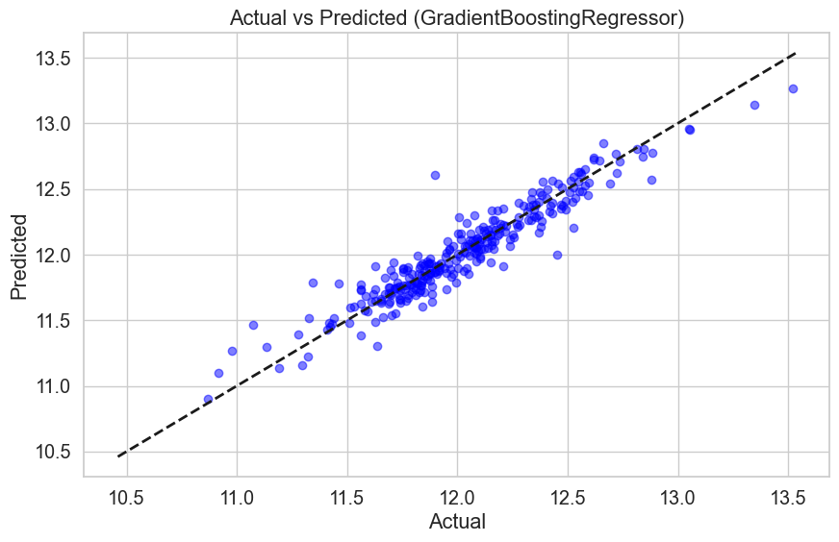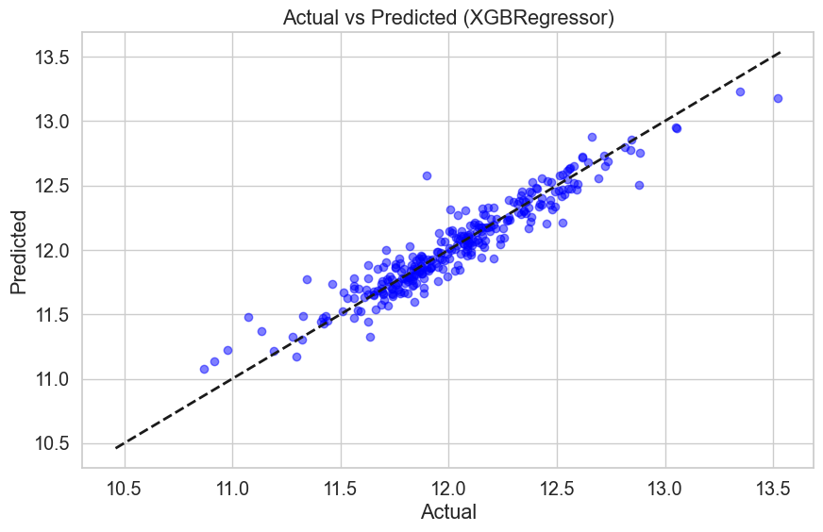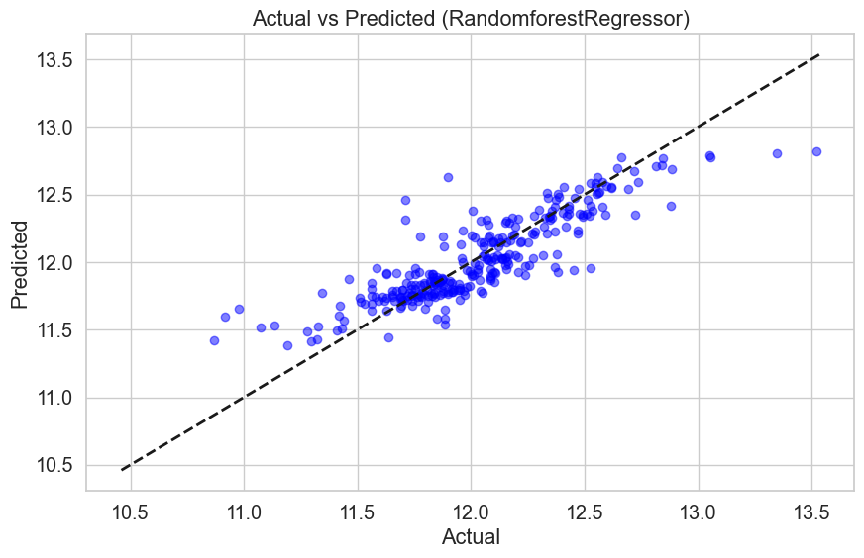

**Report on EDA (Exploratory Data Analysis):**

The EDA phase involved analysing the dataset to gain insights into the distribution of features, relationships between variables, and identifying potential outliers. Visualizations such as histograms, scatter plots, and box plots were used to explore the data.

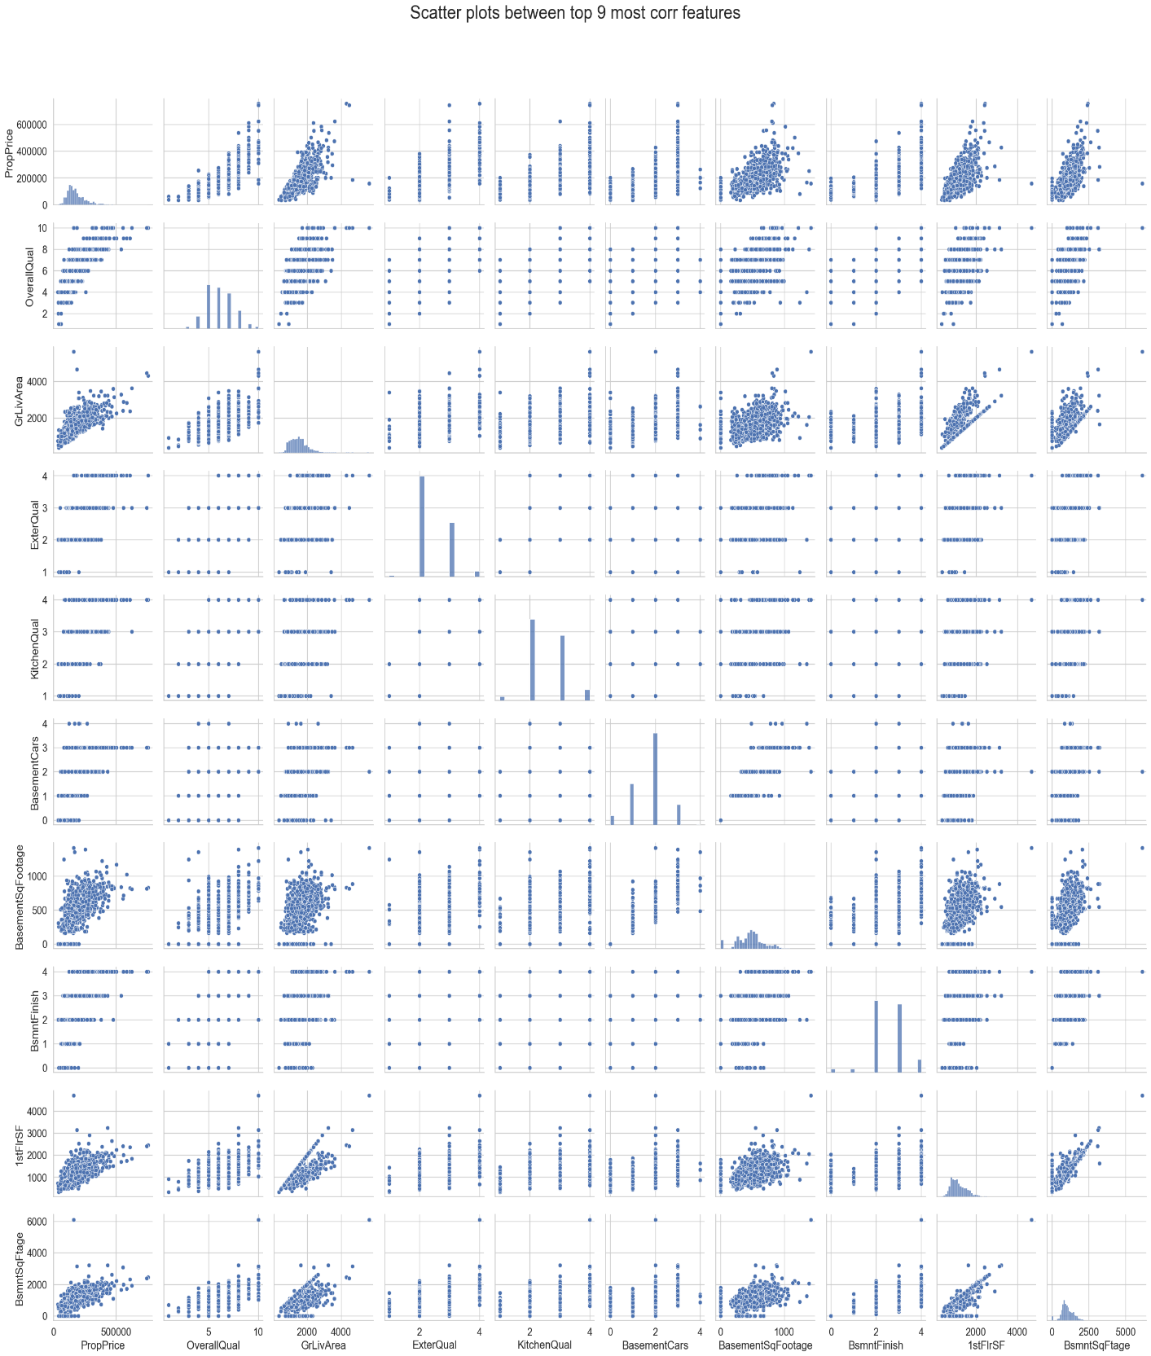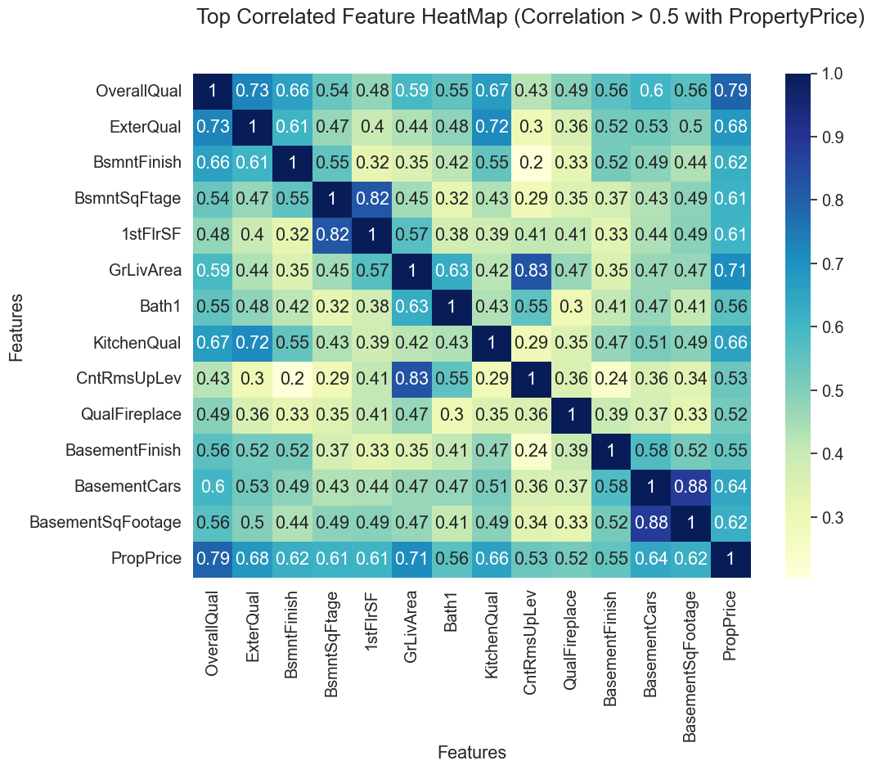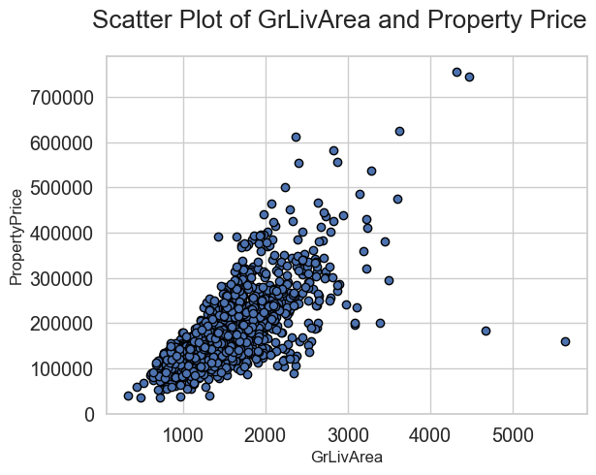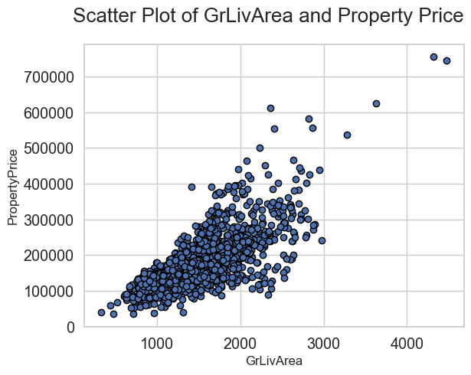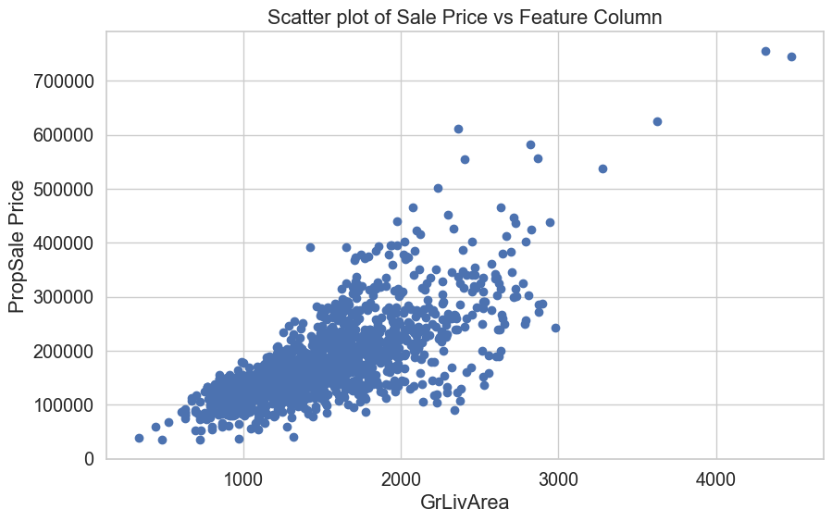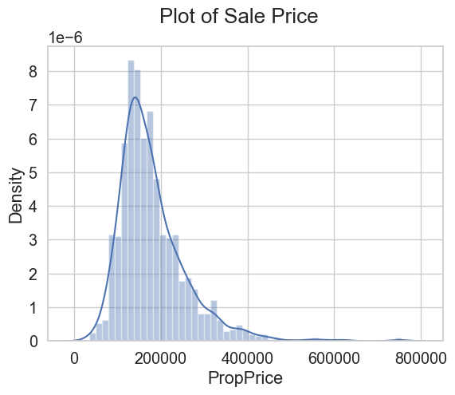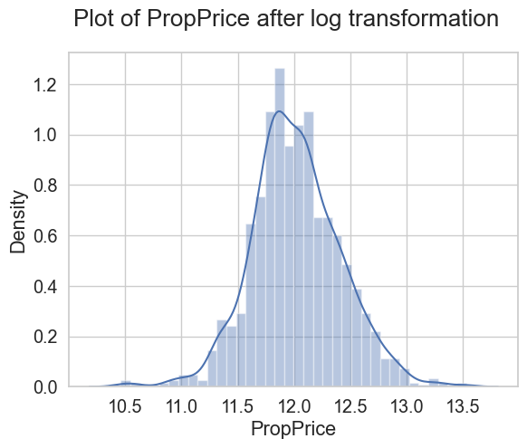

BEFORE IMPUTATION OF PROPERTY FRONTAGE COLUMN

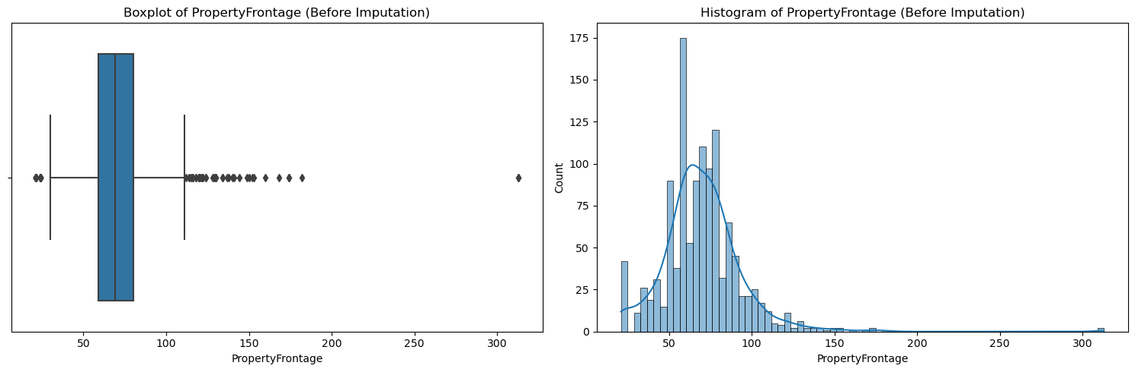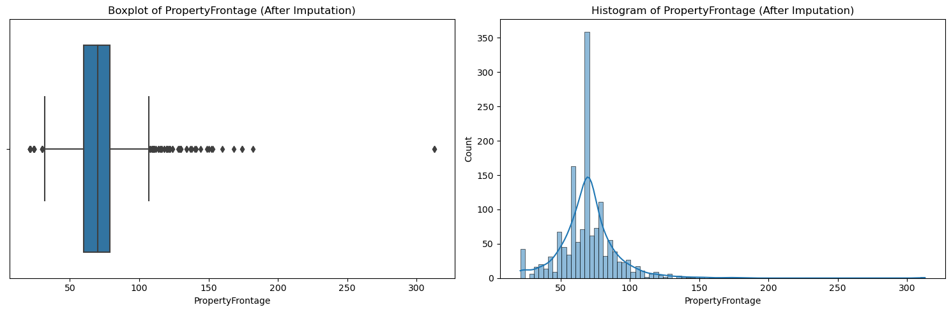

AFTER IMPUTATION OF PROPERTY FRONTAGE COLUMN

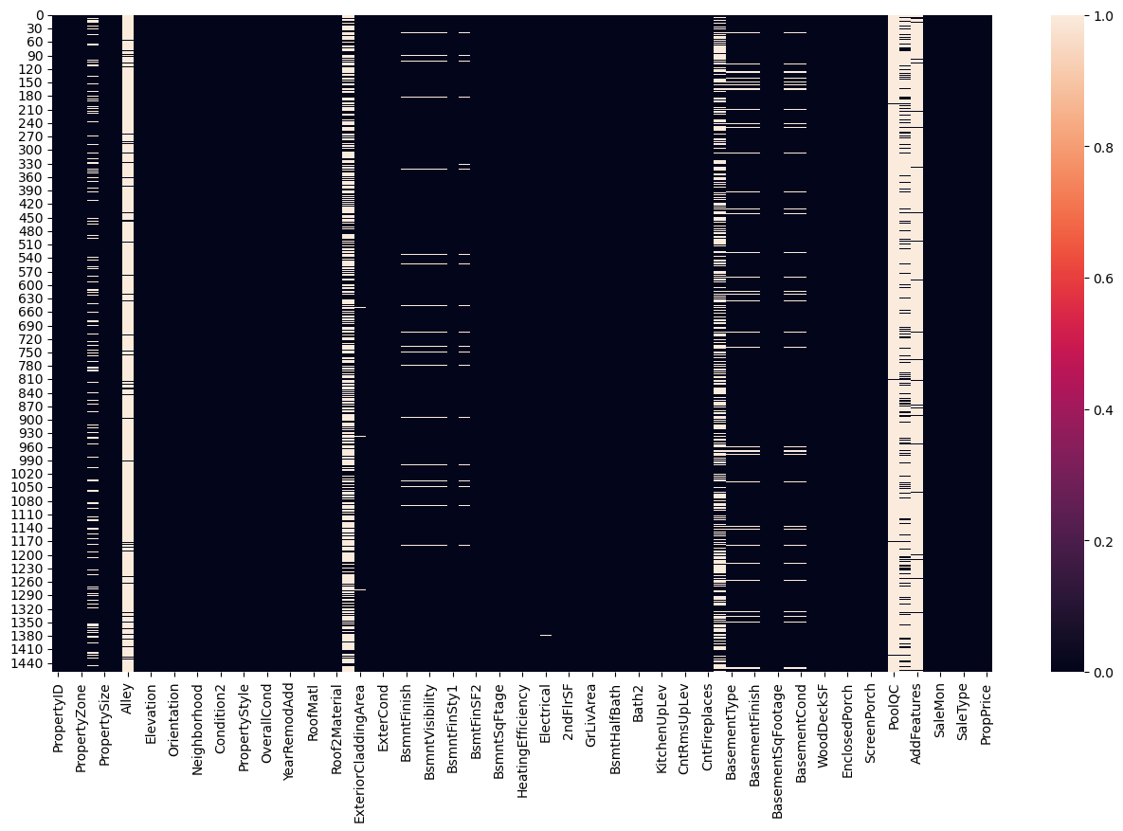

HEATMAP BEFORE TREATING MISSING VALUES

HEATMAP AFTER TREATING NULL VALUES

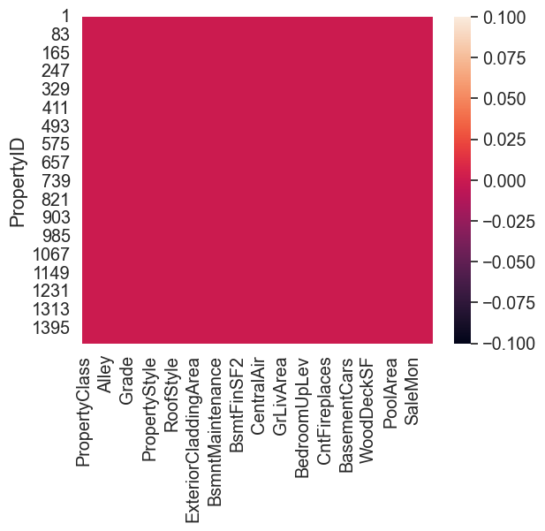

**OUTPUT VALUES**

**MODEL R2 SCORE RMSE SCORE**

**1.K-NEIGHBOURS REGRESSOR -** **0.771287059954 - 0.190400712429192**

**2.GRADIENT BOOSTING REGRESSOR -** **0.962433185575 - 0.077165892830943**

**3.XGB REGRESSOR -** **0.9571441670254262 - 0824191575600603**

**4.RANDOM FOREST REGRESSOR -** **0.793736262215915 - 0.180815077759306**

**5.SUPPORT VECTOR MACHIE -** **0.961539100637388 -0.0780787619710301**

**6.DECISION TREE REGRESSOR - 0.8512354155485912 -0.1535581875409845**

**7.GRADIENT BOOSTING WITH**

**HYPERPARAMETER TUNING - 0.9706777498819038 - 0.068174482143490**

**CONCLUSION:**

In conclusion, this project successfully developed a predictive model for property price estimation using machine learning techniques. Through data preprocessing, model training, and evaluation, valuable insights were gained into the factors influencing property prices. The model can be further improved by incorporating additional features and exploring advanced algorithms.

**CITATIONS –**

**Websites used for research include –**

[**https://scikit-learn.org/**](https://scikit-learn.org/)

[**https://www.kaggle.com/**](https://www.kaggle.com/)

[**https://www.geeksforgeeks.org/**](https://www.geeksforgeeks.org/)

**NAME: S. SUJANA KUMARI  
AFFILIATION: DIGICROME ACADEMY**